**ASSIGNMENT-13**

**H NO: 2403A52139**

* **Task 1: Translate a Simple Program (Python → JavaScript)**
* **Instructions:**
  + Write a Python function print_numbers() that prints the first 10 natural numbers using a loop.
  + Translate the function into JavaScript as a reusable function printNumbers().
  + Call the function in both languages to display results.
* **Expected Output:**
* **1**
* **2**
* **3**
* **...10**

**CODE AND OUTPUTS**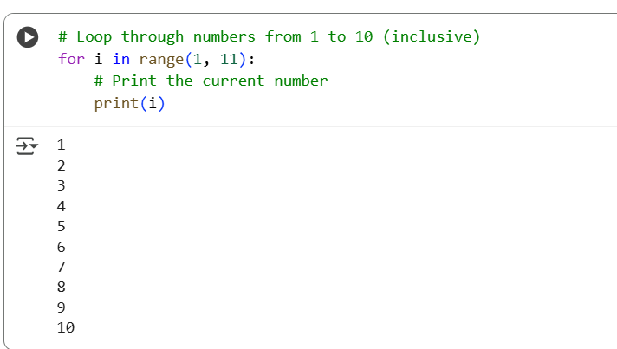

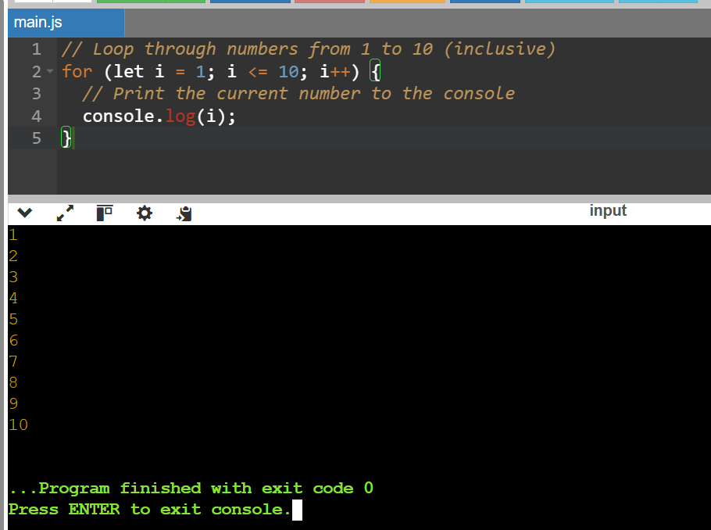

* **Task 2: Convert Conditional Statements (Java → Python)**
* **Instructions:**
  + Write a Java method checkNumber(int num) that checks if a number is positive, negative, or zero.
  + Translate the method into a Python function check_number(num).
  + Call the function/method with different inputs and compare outputs**.**
* **Expected Output:**
  1. Input: -5 → Output: The number is negative
  2. Input: 0 → Output: The number is zero
  3. Input: 7 → Output: The number is positive

**CODE AND OUTPUTS**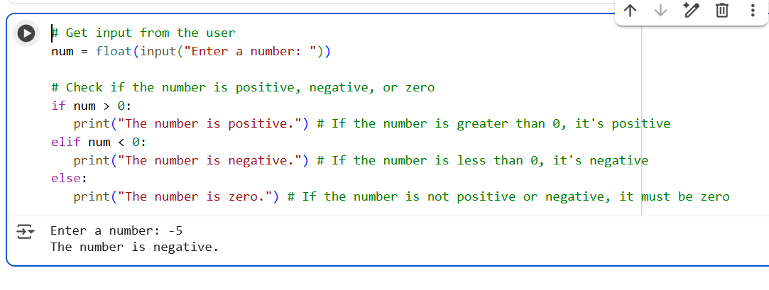

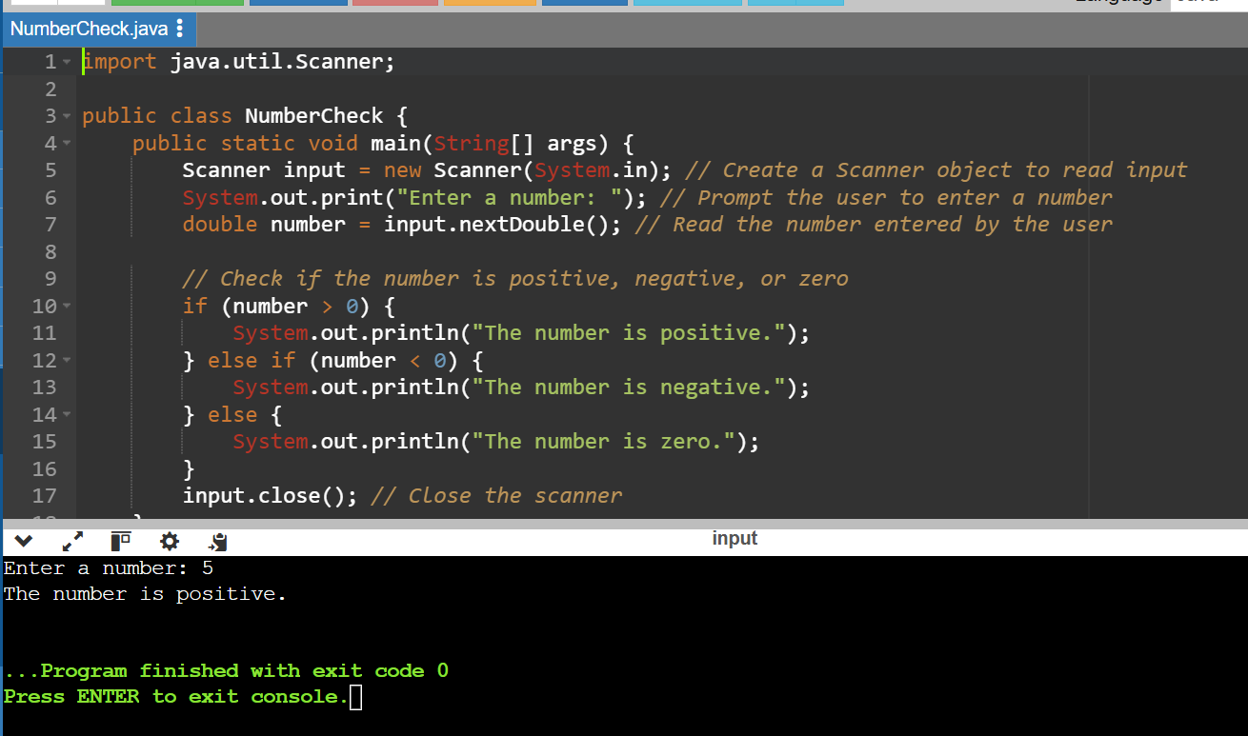

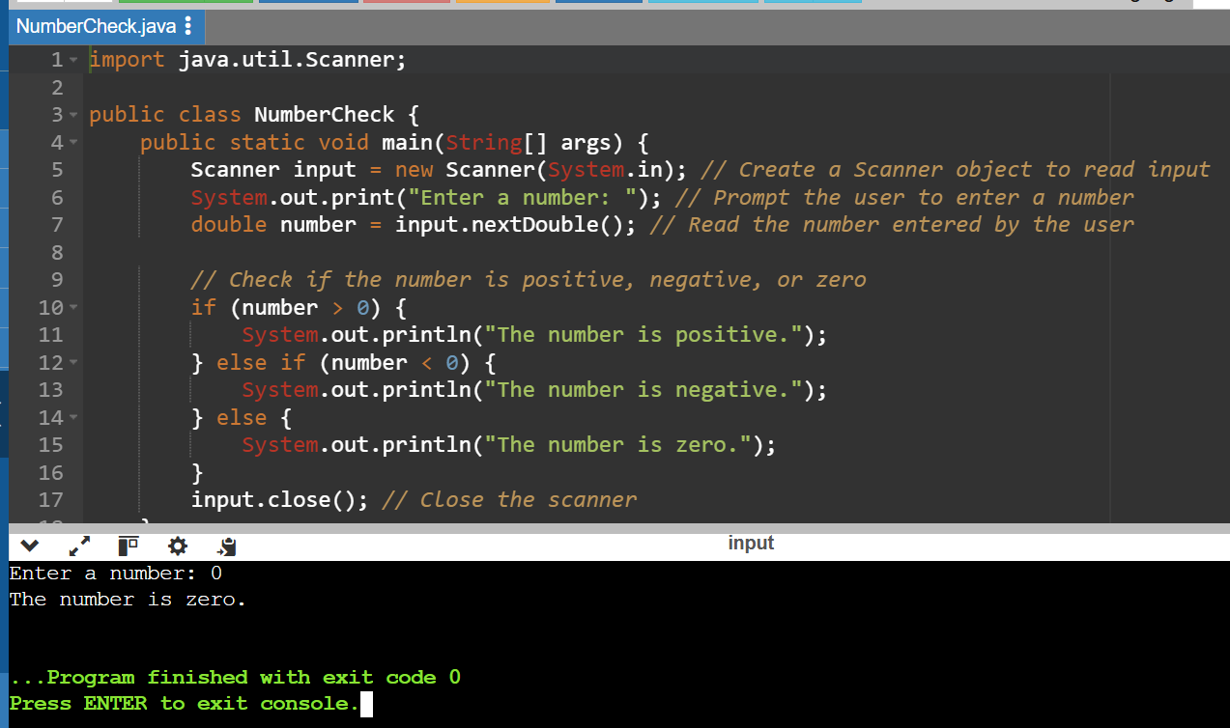

* **Task 3: Translate Recursive Function (Python → C++)**
* **Instructions:**
  + Write a Python function factorial(n) that calculates factorial of a number using recursion.
  + Translate the same into a C++ function int factorial(int n).
  + Call the function in both languages with inputs 5 and 0.
* **Expected Output:**
  1. **Input: 5 → Output: Factorial = 120**
  2. **Input: 0 → Output: Factorial = 1**

**CODE AND OUTPUTS**

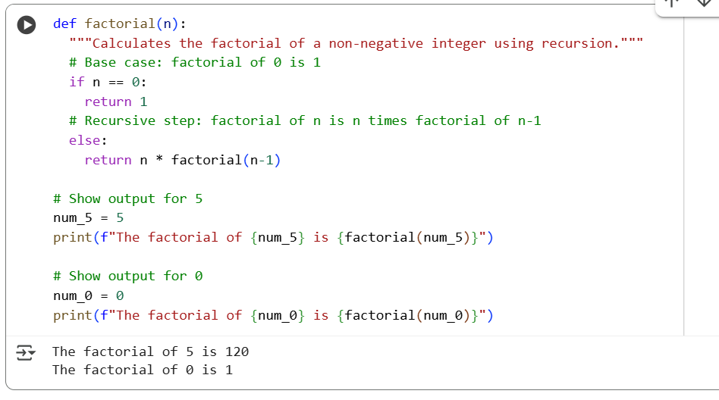

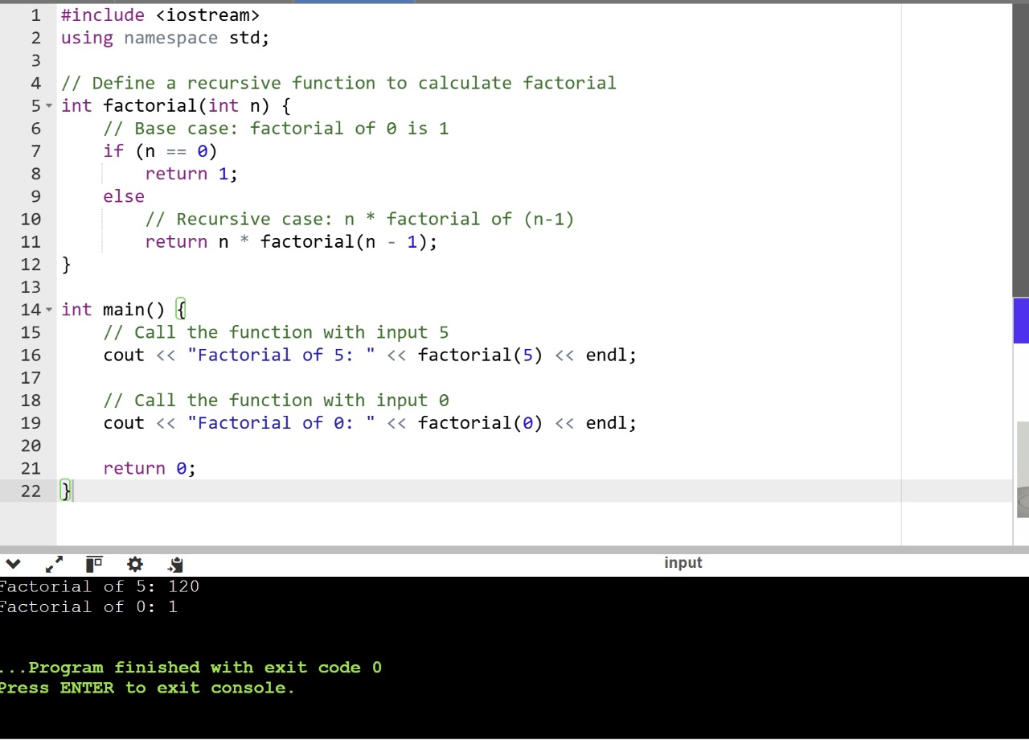

* **Task 4: Data Structures with Functions (JavaScript → Python)**

**Instructions:**

* + Write a JavaScript function printStudents(students) that takes an array of student names and prints each name.
  + Translate it into a Python function print_students(students) using a list.
  + Test both functions with sample student names**.**
* **Expected Output:**
* Student List:
* Alice
* Bob
* Charlie

**CODE AND OUTPUTS**

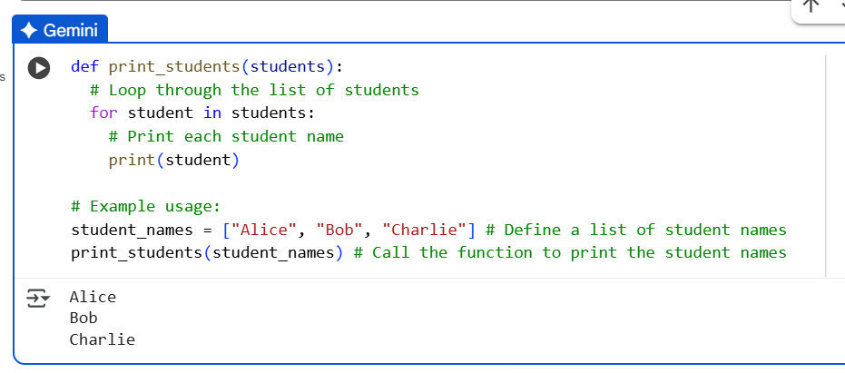

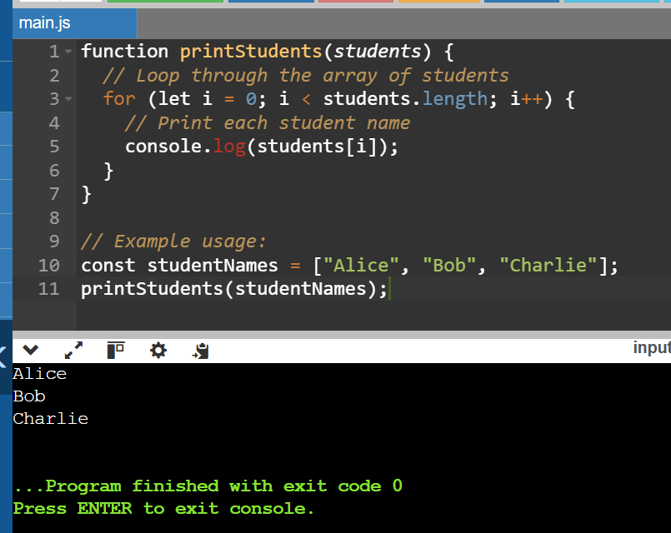

* **Task 5: Class & Object Translation (Python → Java)**
* **Instructions:**
  1. Write a **Python class** Car with attributes: brand, model, year.
  2. Add a **method** display_details() that prints car details.
  3. Translate the same into a **Java class** Car with attributes and a **method** displayDetails().
  4. Create an object in both languages and call the method.
* **Expected Output:**
* Car Details:
* Brand: Toyota
* Model: Corolla

Year: 2020

**CODE AND OUTPUTS**

